User Php

Open the website you will see the home page.

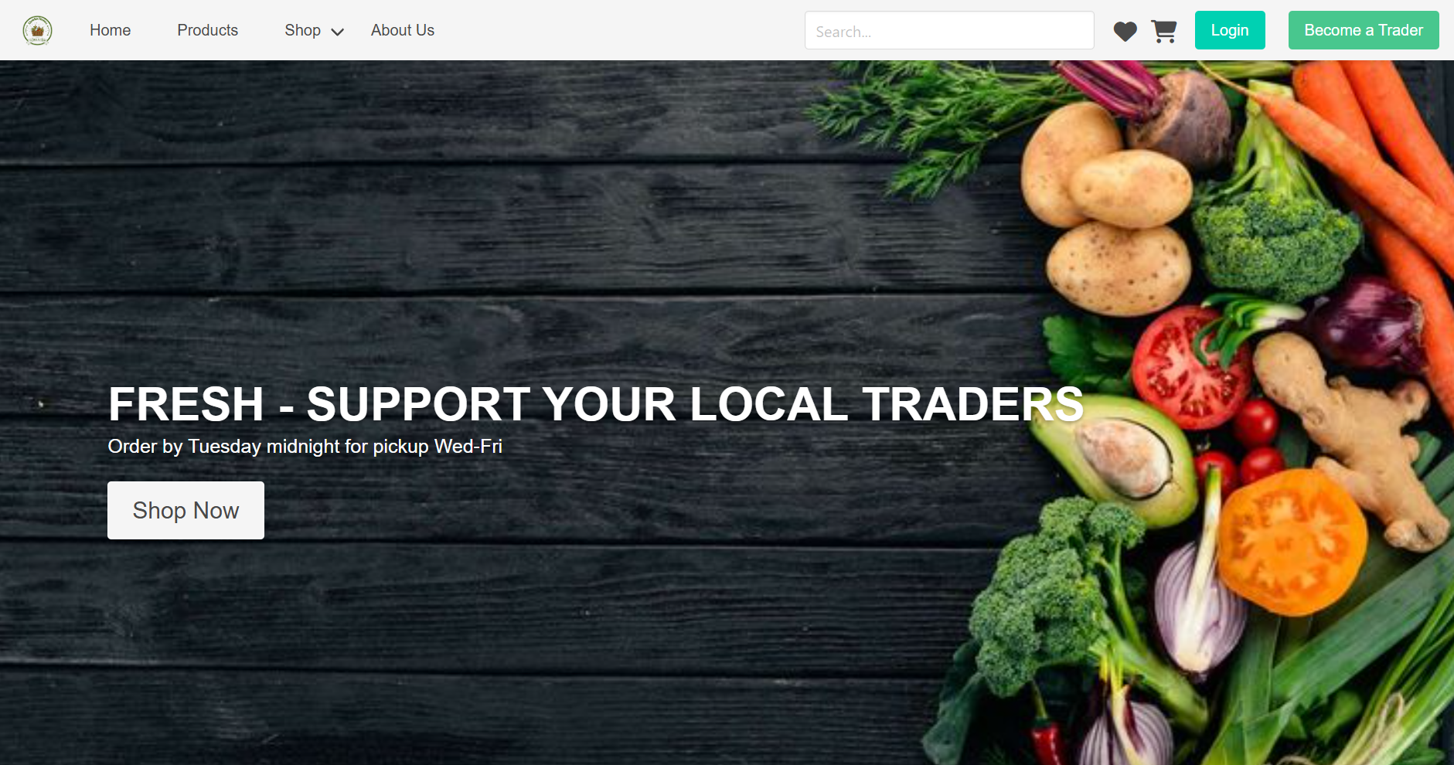

You can see do the window shopping here as you are not logged in. To have access other you have to login.click the login button to sign in. you will see the below page.

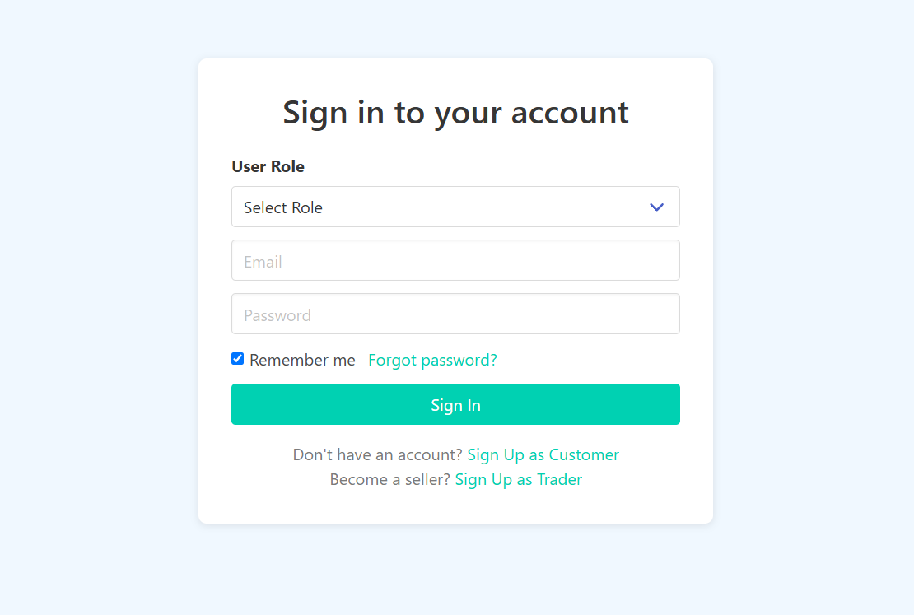

If you don’t have a account sign up using the sign up as a customer. Make sure you enter valid email and don’t try use the same email. Make sure to enter a valid number with other details.

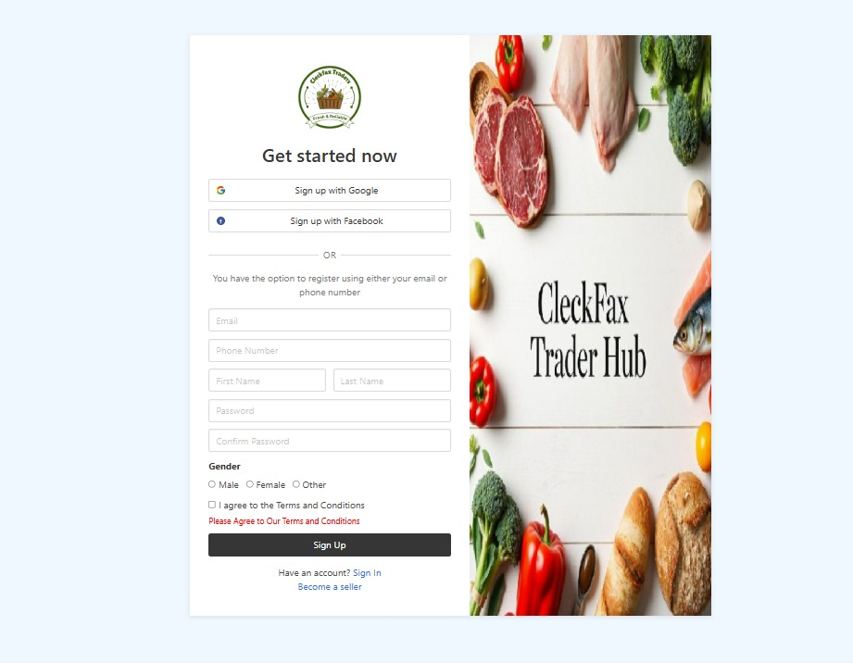

Then verify your email using the otp in sent to your email used during the signup.

Make sure you enter correct code otherwise it show error.

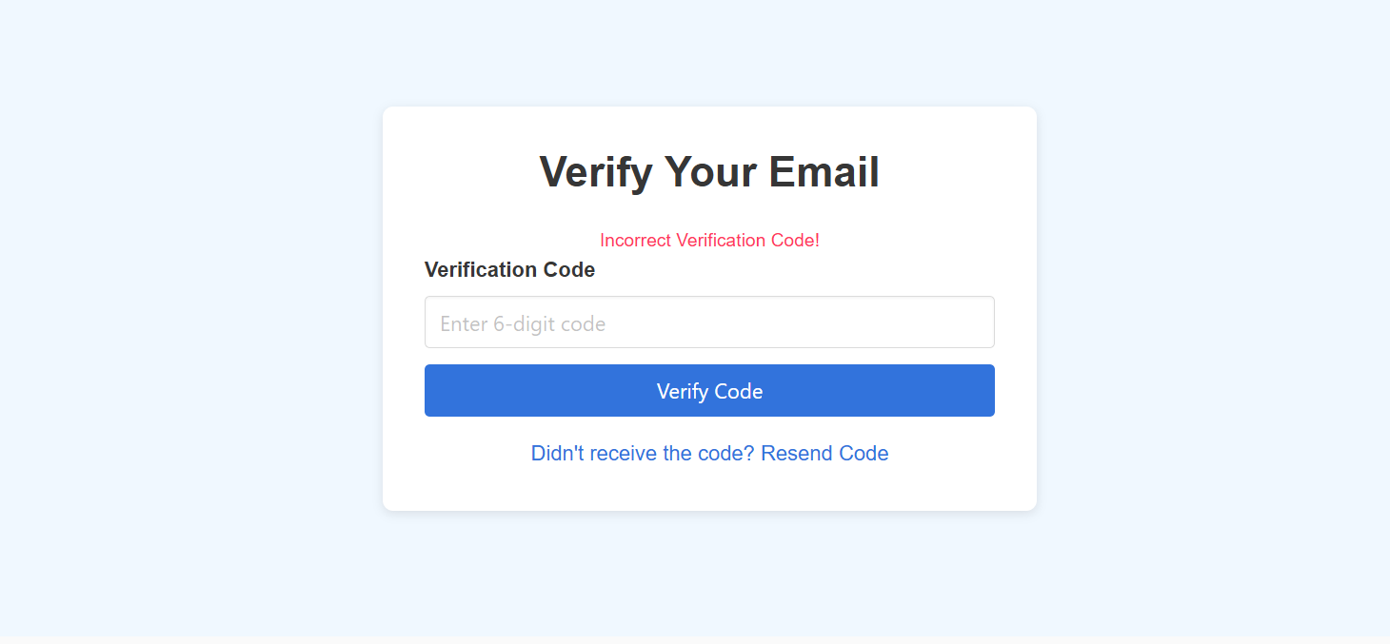

Then login using your credentials. make sure you enter your valid credentials.

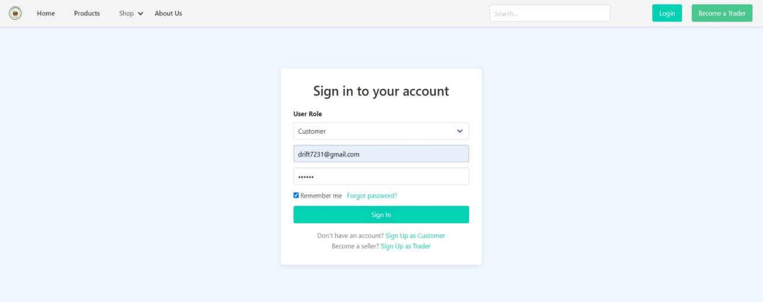

IF not registered properly you will see the this error.

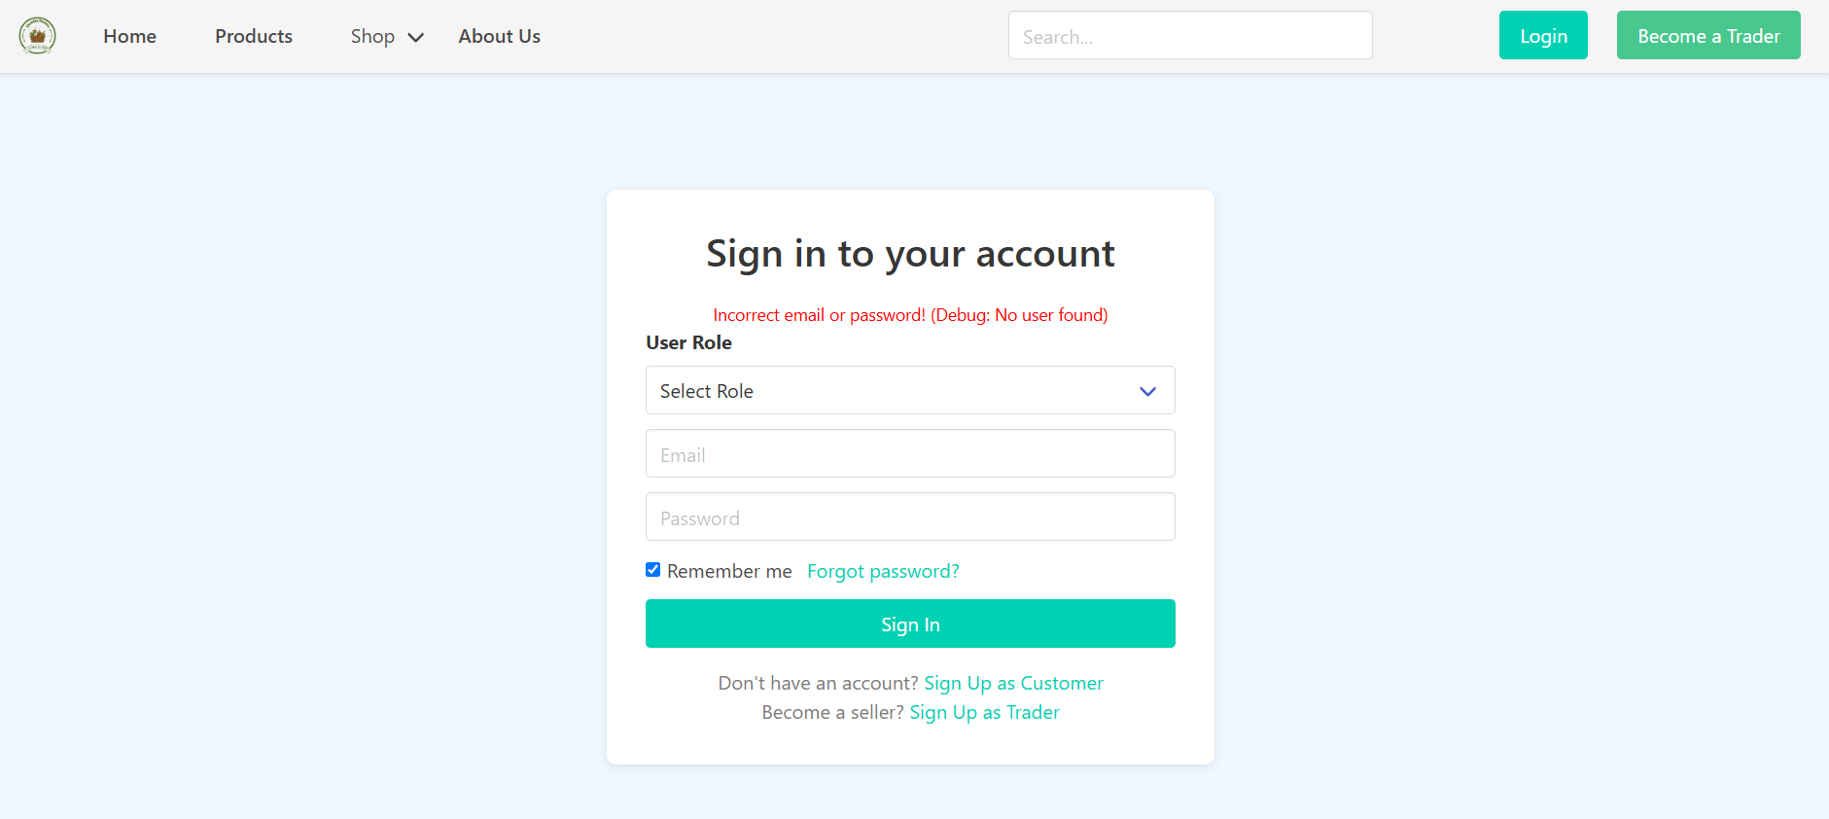

After being logged in you can see your name in navbar. 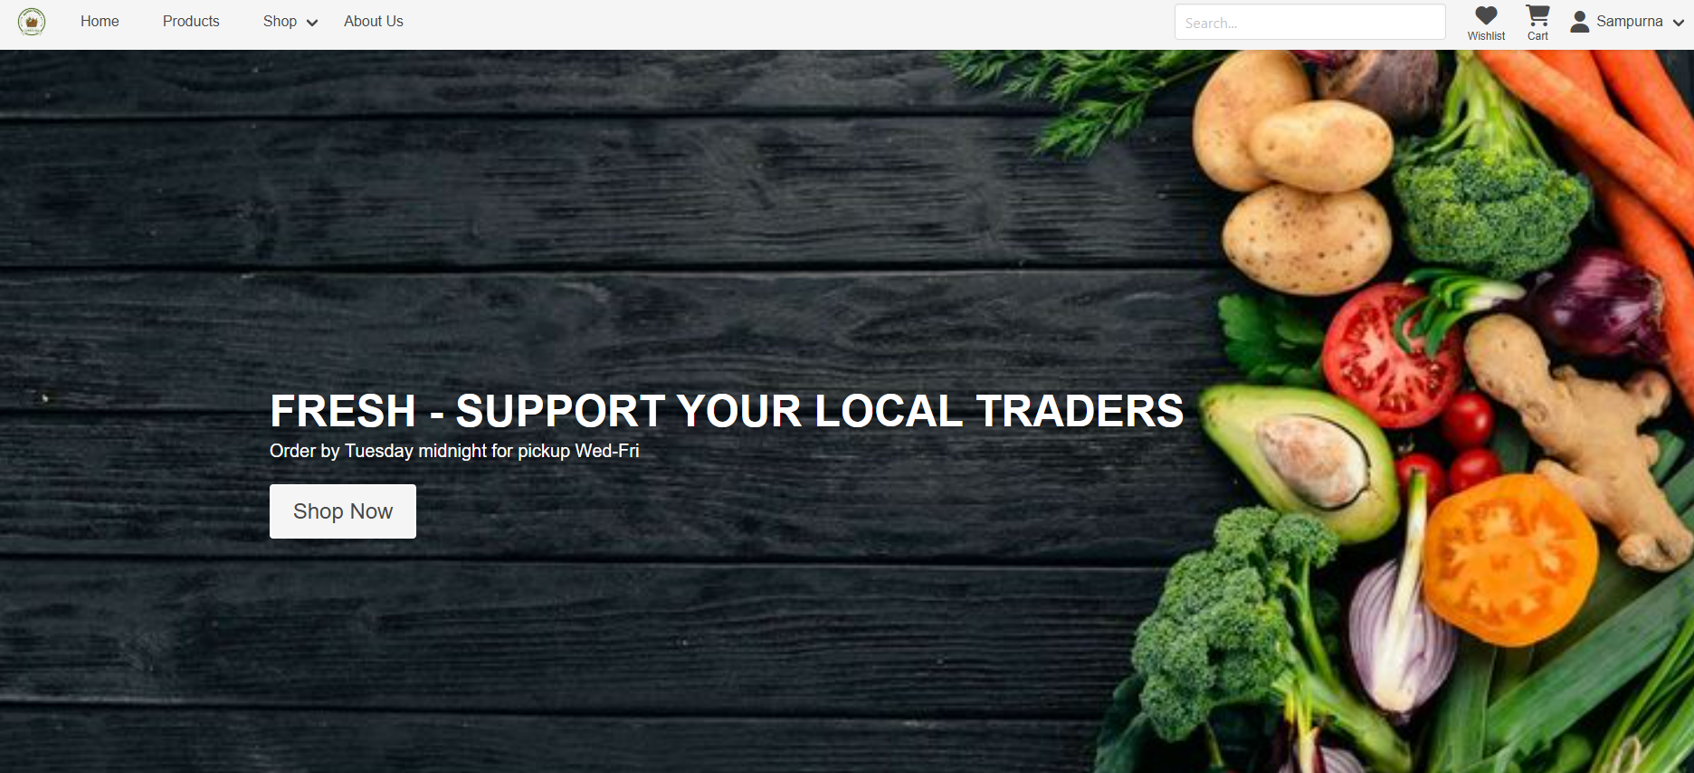

Your profile look like this 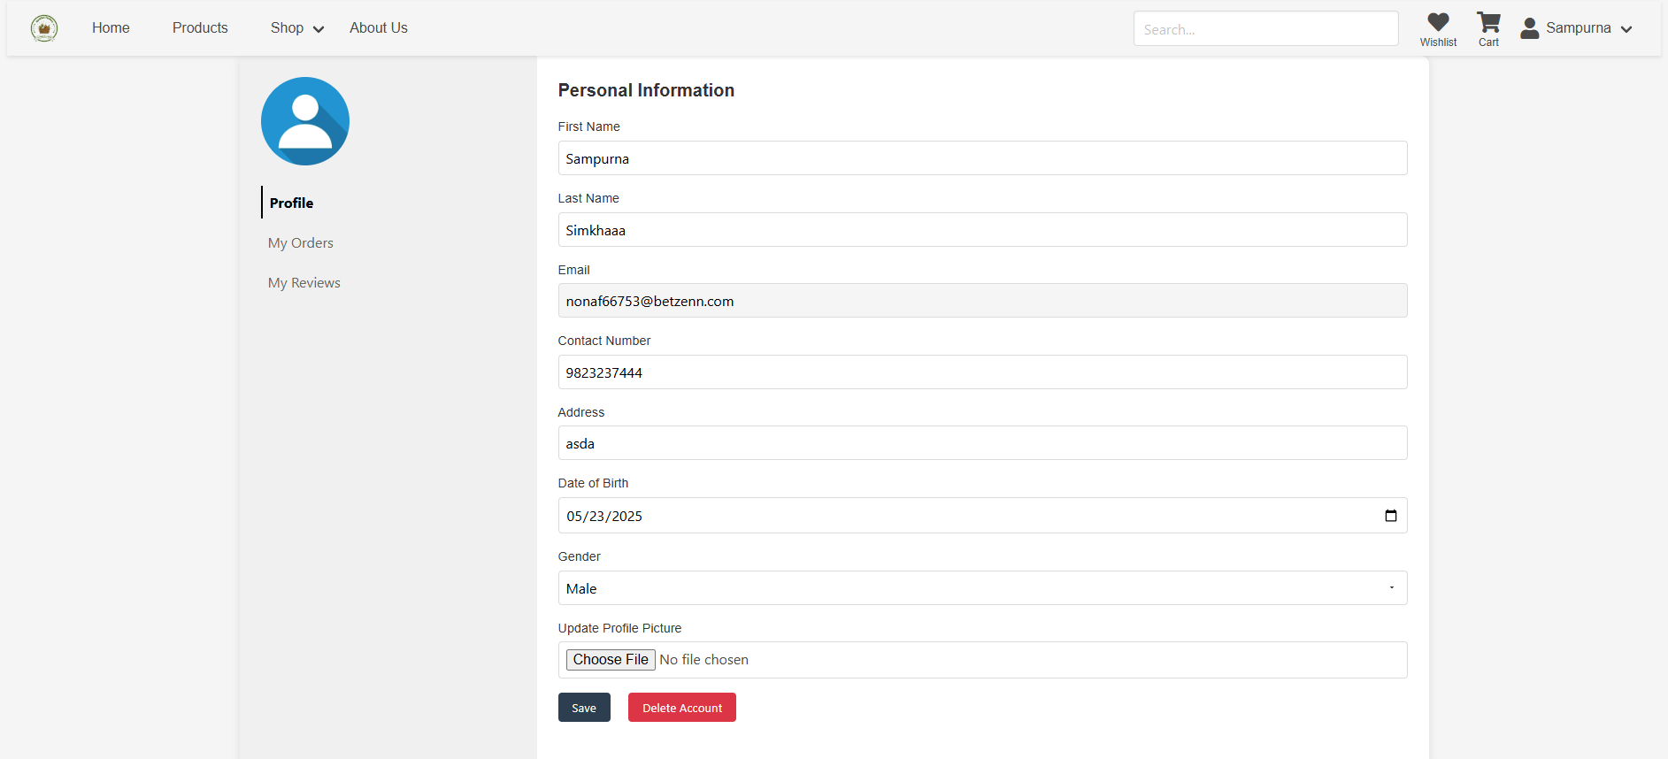

You can access the product list page by clicking the products in the nav bar.

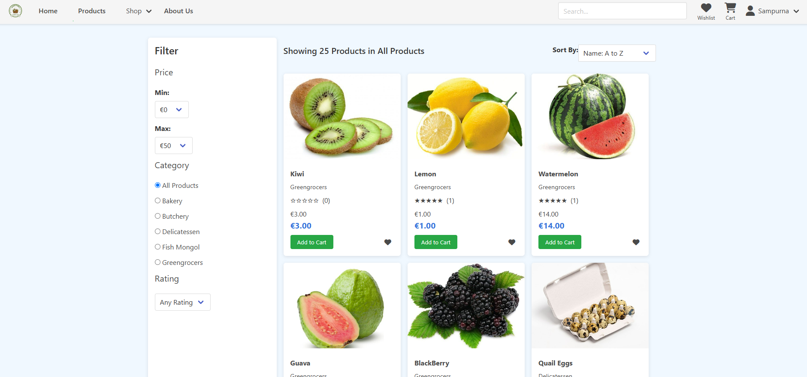

You can access the shop by clicking or hovering over the shop icon on nav bar like this.

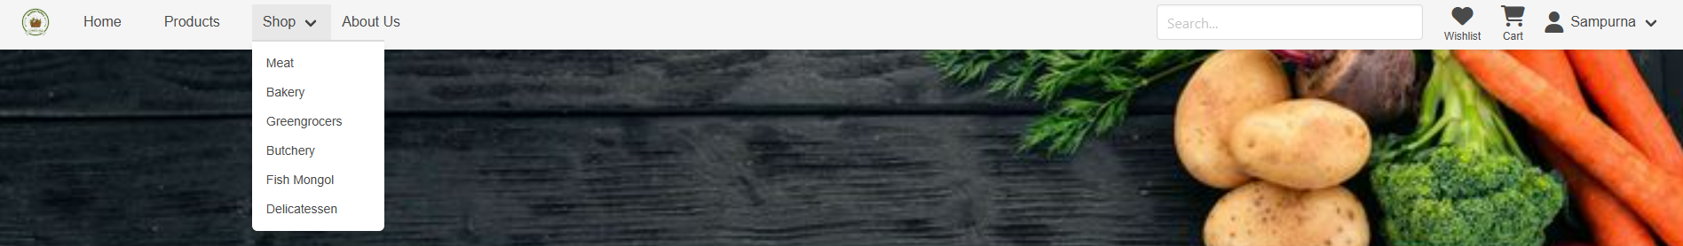

You can also access the shop by clicking the shop.

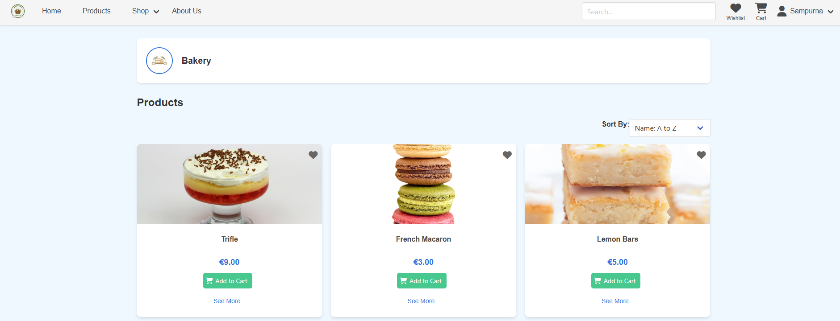

You can get the product by clicking the products which looks like this.

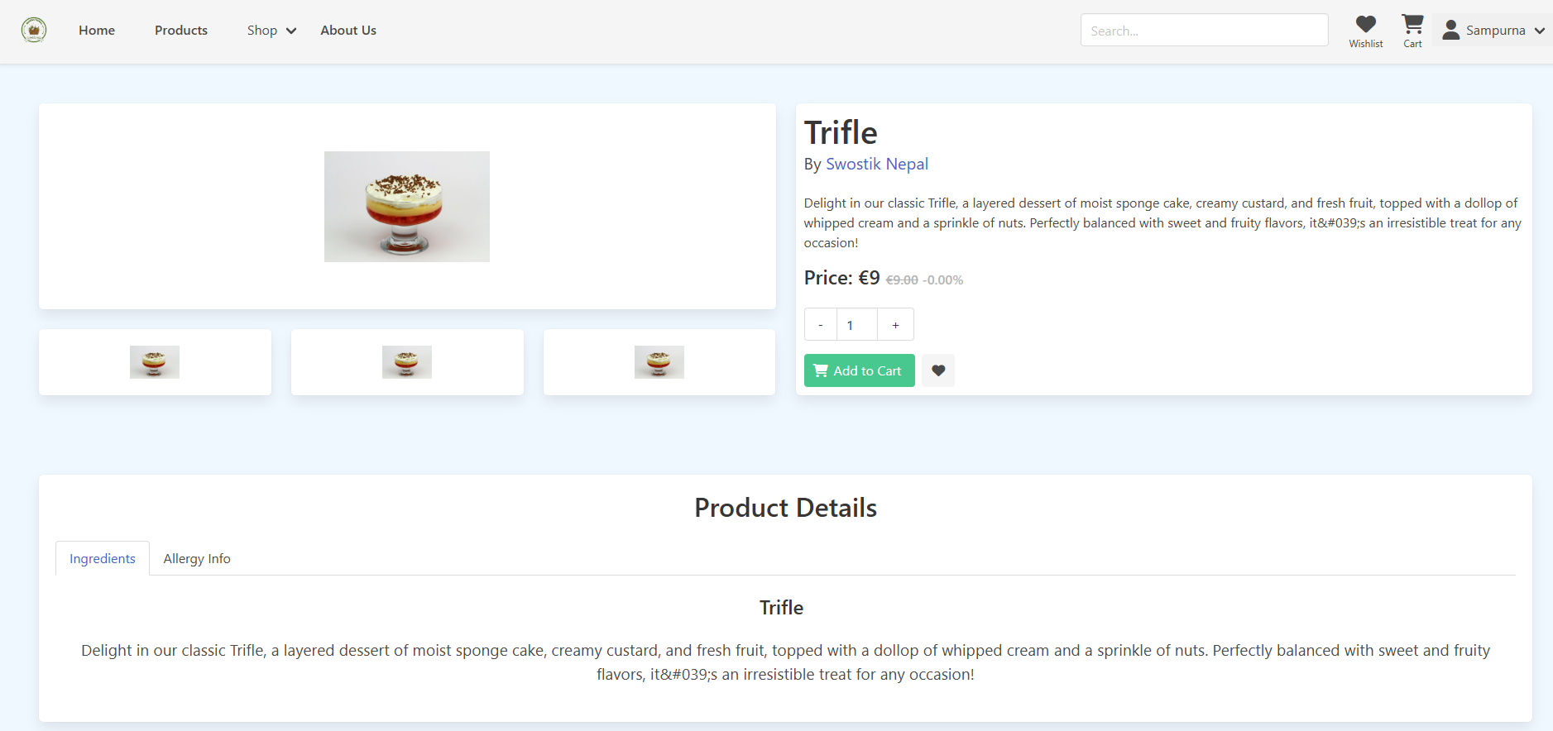

You can also know about our goal and vision in aboutus ge in the nav bar. 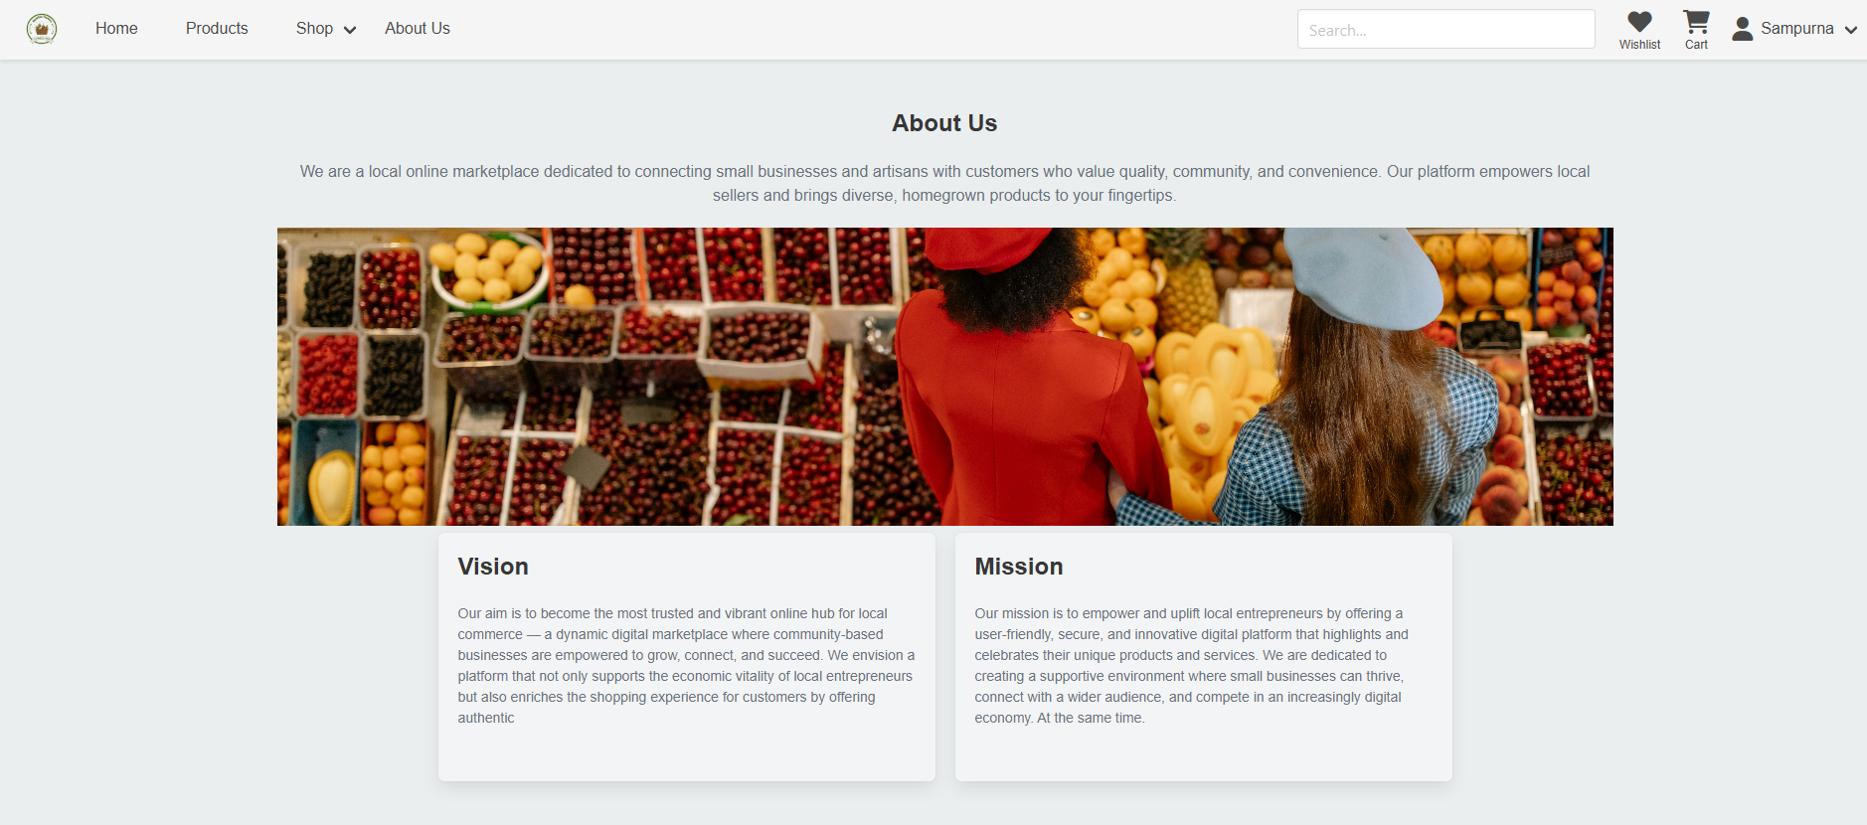

You can also search the product using the search bar . i have searched kiwi which shows kiwi product in the page. Now you can add the product in the cart by clicking the add to cart button.

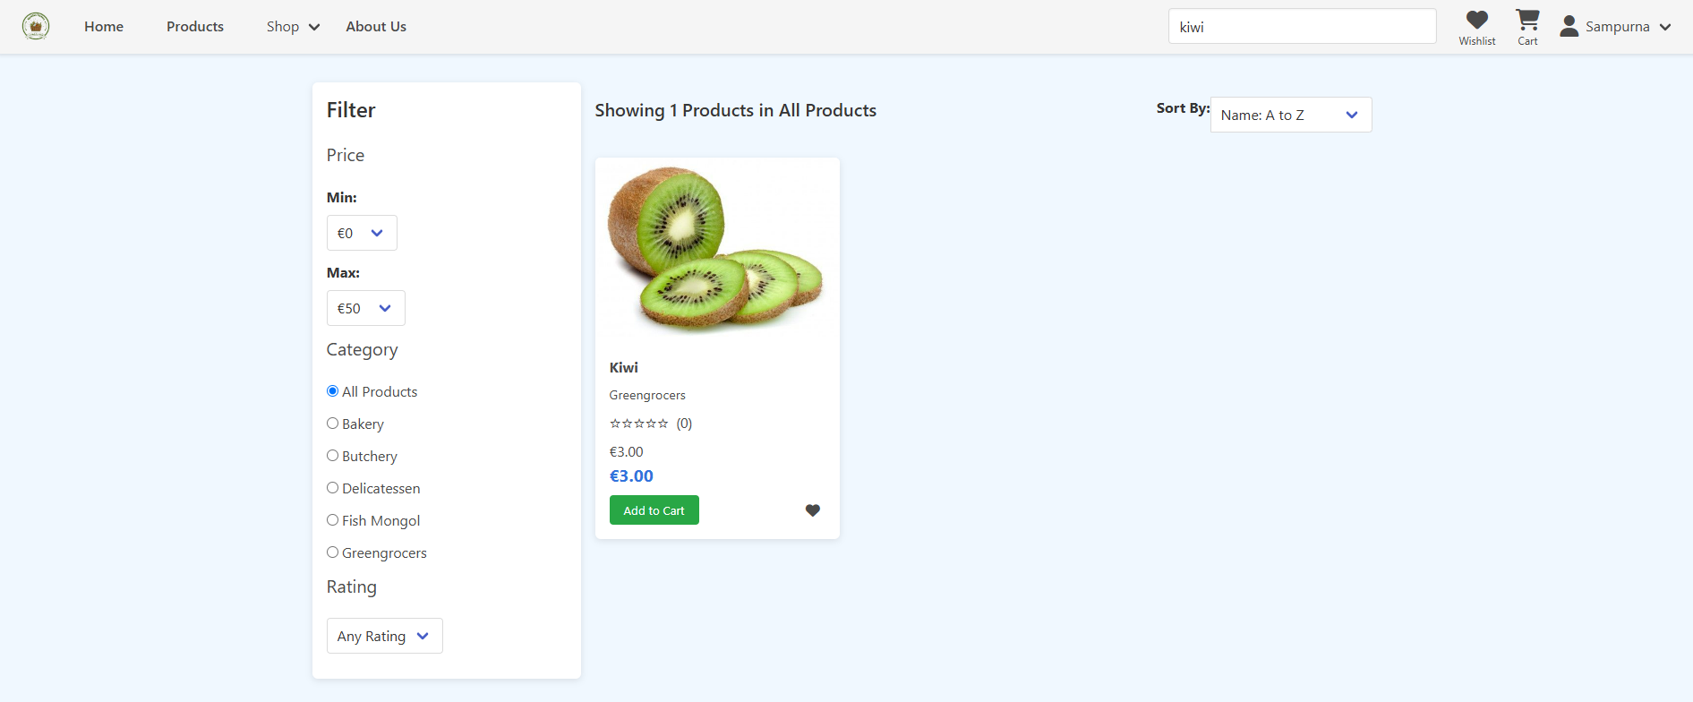

You can also review and rate the product in the product detail.

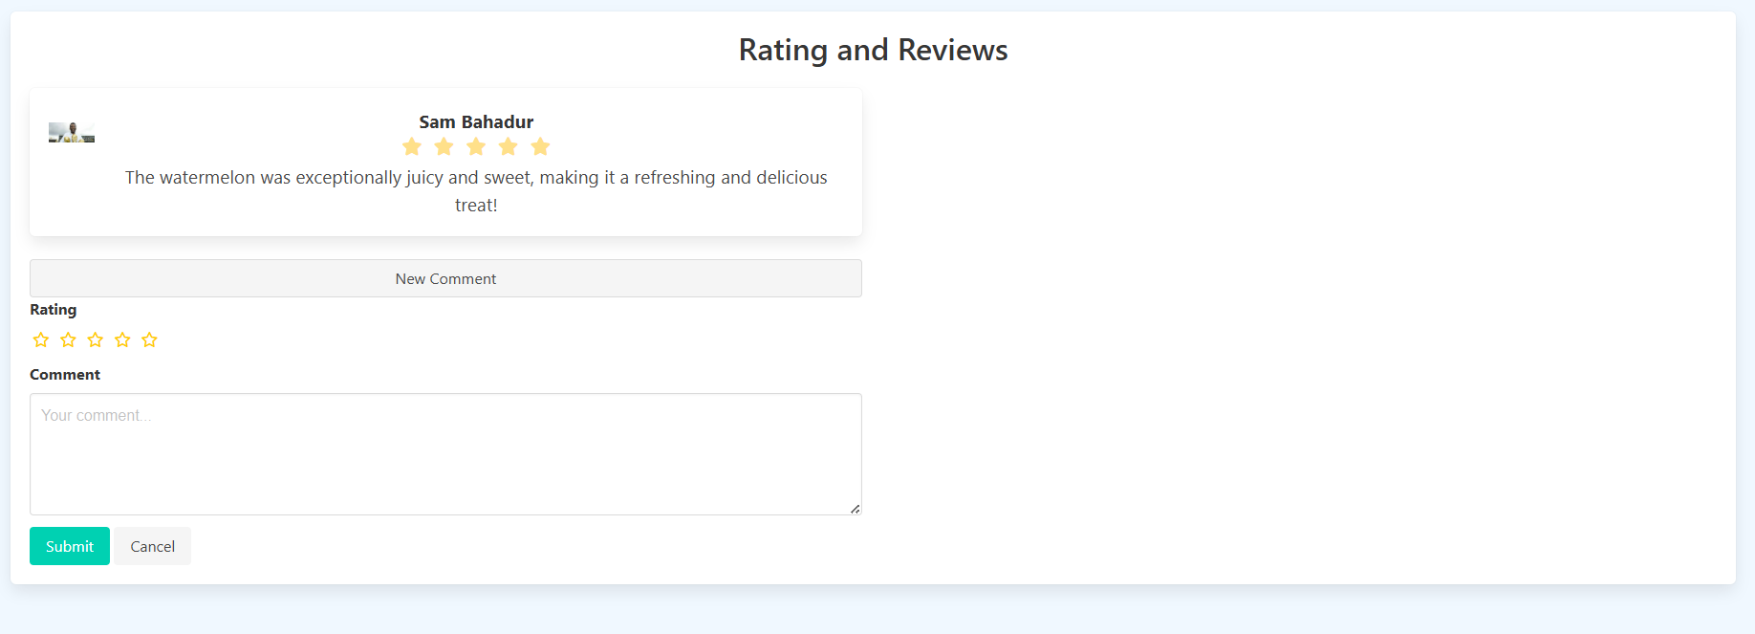

You can add the product to Wishlist by clicking the heart icon. It adds product to the Wishlist.

You can either ad the product to cart or remove it from here.

You 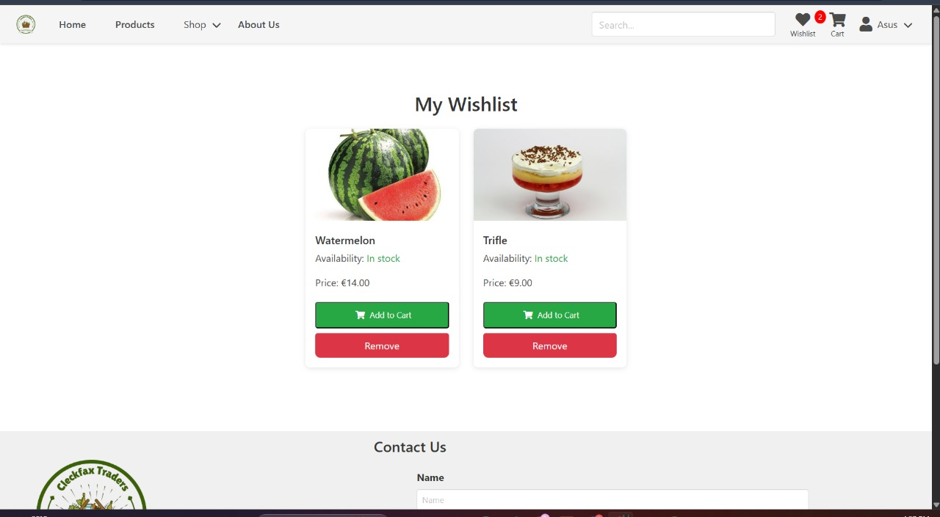

After you add product to the cart click the check box of the product with specific quantity.

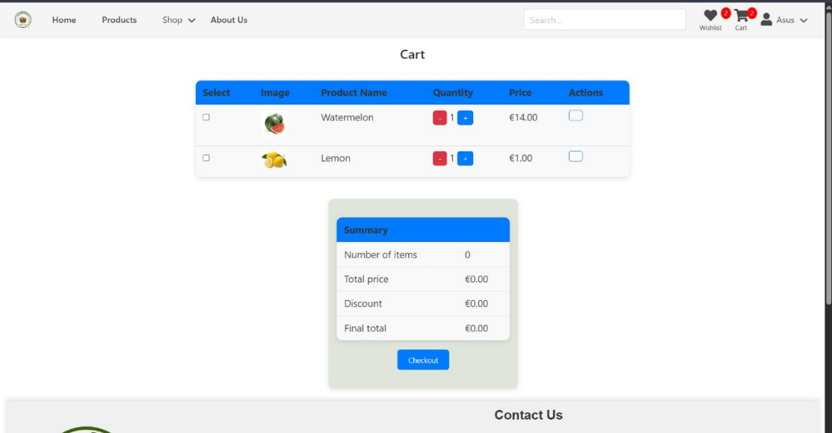

Make sure you have only 20 products in the cart.so make sure you will not exceed it.

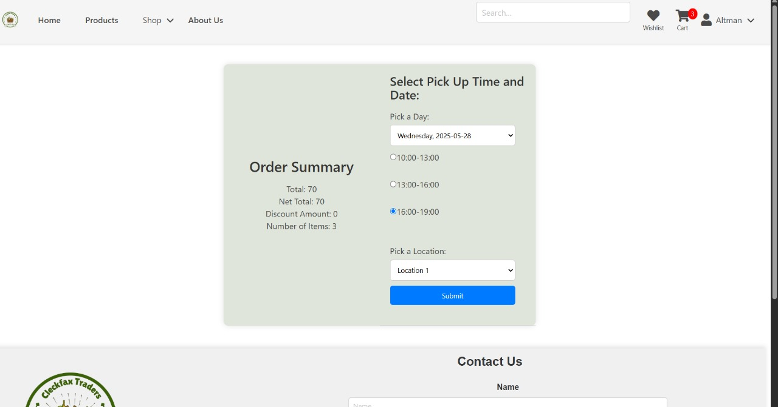

After selecting the product and check out you will proceed to select a pickup time to receive your product. After the submit button you will be directed to payment.



The payment option only has PayPal for now . click procced to PayPal and make the payment for products you purchased

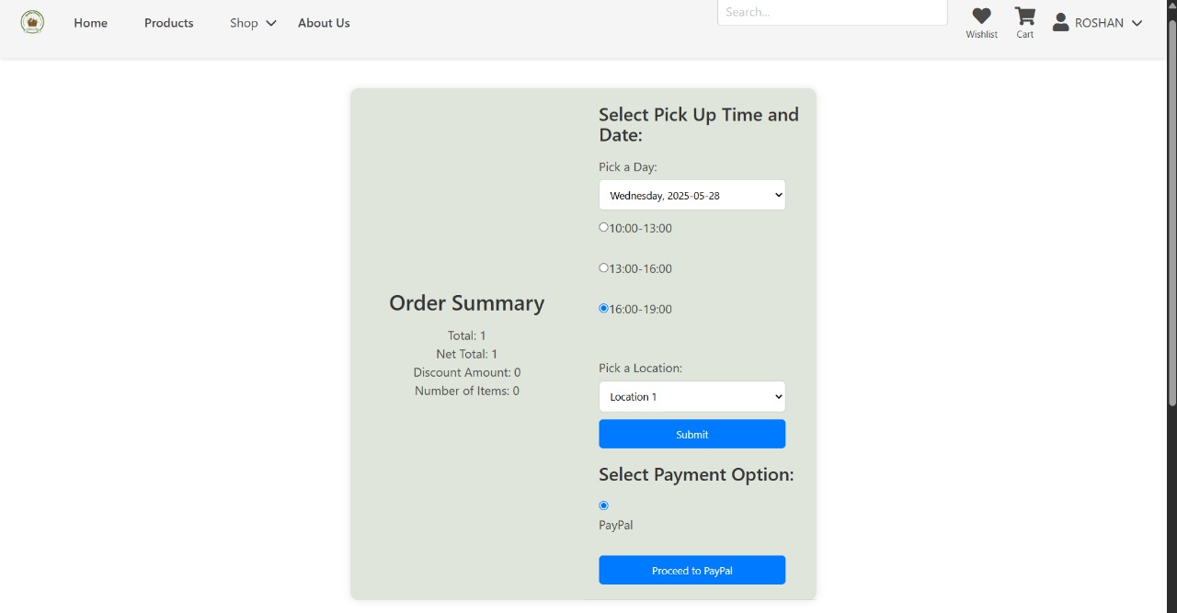

Al last You can logout by hovering over the profile icon. 